Greenworks User Manual

Introduction

The Purpose of this document is to provide the necessary information that a user would require to navigate through the basic tools available in the application. This document will also discuss the purpose of the project and how it will affect the city of Orlando. The completion date for this project is April 28, 2022.

Scope

This manual will not cover admin-related operations. This document will provide a guide through the features relegated to the user when navigating the web map

Contents

A Quick Look at the Basics 3

Filter – Desktop Version 4

Filter - Mobile Version 5

Advanced Filter 6

Zoom in / Zoom out 6

Events / Calendar 7

List View 8

# A Quick Look at the Basics

Greenworks Orlando provides you with an **interactive map** of the city that shows **environmentally friendly initiatives**, events, and general information such as electric charging stations, water stations, parks, recycling stations, bus stops, bike trails, and more.

* **Clean Energy**
* **Clean Water**
* **Electric & Alt. Transportation**
* **Green Buildings**
* **Livability**
* **Local Food Systems**
* **Zero Waste**

Mobile Version - Default View

You can easily navigate the map by clicking/touching and holding on any portion of it. Then move around and be sure to check out the new events and ecofriendly hubs near you. To get more details, just click on an icon location and a box with more details will pop up on your screen.



Desktop Version - Default View

What Are the Key Features of Greenworks Map?

# Filter – Desktop Version

This ecomap has 7 different types of locations, and they are represented by the icons below. In the **desktop version**, you can filter which categories you would like to see on the map by clicking on the respective icons (they will turn gray and become inactive). Click once again to reverse.

This icon represents the Clean Energy locations (Sollar Arrays, Resilience Hubs and Solar Tables).

 This icon represents s the Clean Water locations (Hydration Stations, Wetland Parks, Waste and Potable Water Plants).

 This icon represents the Electric & Alt. Transportation (EV Charging Stations, Bike Trails, and Bus Stops).

 This icon represents the Green Buildings (LEED/Energy Star/Green Globe).

 This icon represents the Livability (Historic trees of Significance and Iconic Parks and Neighborhood Centers).

 This icon represents the Local Food System (Farmers markets, Community gardens, Urban farms, and Apiaries).

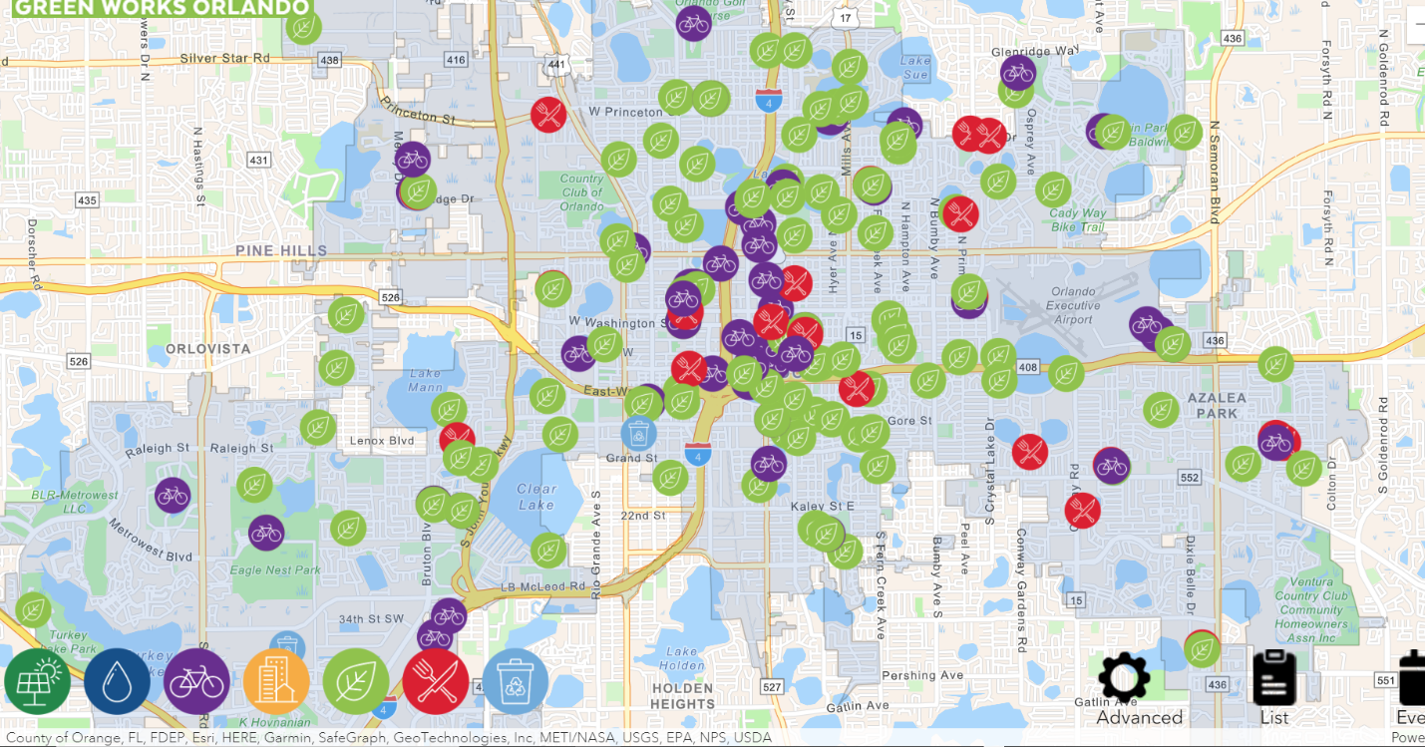 This icon represents the Zero Waste (Recycling and Food Waste drop-offs, Hazardous Waste Facility and Recycling Transfer Stations).

.

# Filter - Mobile Version

It works very similarly in the **mobile version**¸ however the filter menu will be located on the top left of your screen. Touch to hide a category from the map and repeat the process to show it again.

* You can hide one or more of them at the same time

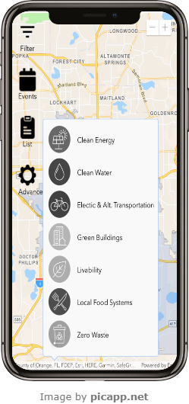

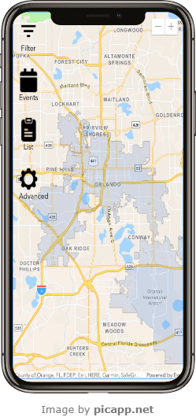

# Advanced Filter

if you need to narrow down your search, you can use the advanced filter tool and select to hide/show icons by subcategory.

# 

# Zoom in / Zoom out

Click Zoom In or Zoom Out to move closer to or further away from the current location.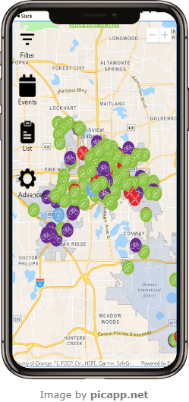

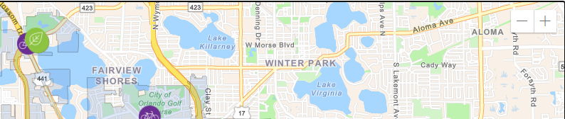

# Events / Calendar

To see events on specific days, select the “events” button on the bottom left of the map (desktop version) or on the top left of the screen (mobile version)

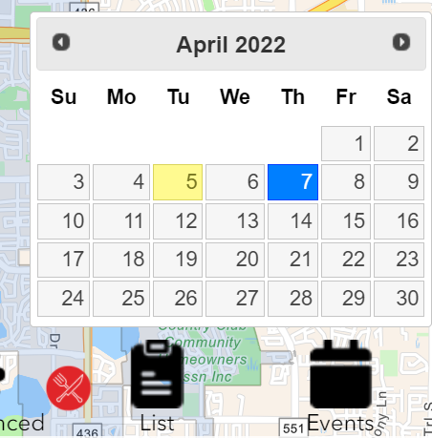

Once selected, you will see a calendar with the option to select a specific day to see which events will be available that day

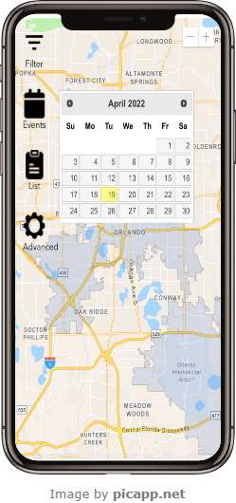

*NOTE* once you select in the calendar, all the symbols will disappear, and map will show only the events from the chosen day. To bring the hidden symbols back up, simply select the corresponding icons in the filter on the bottom left of the screen (desktop version) or on the top left of the screen (mobile version).

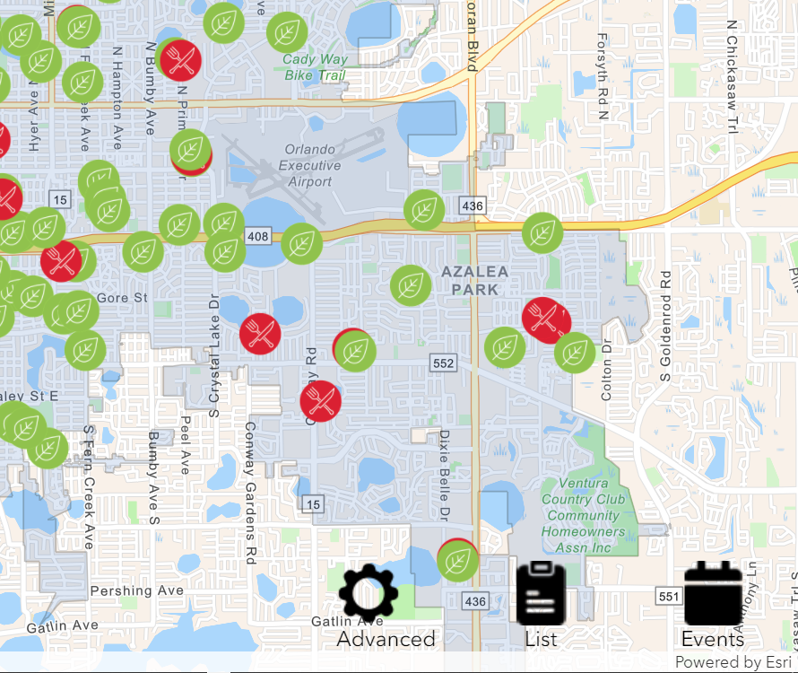

# List View

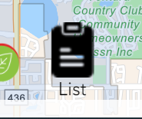You can also access a list with all the locations currently displayed on the map, in alphabetic order, you have the option to click on the “list” button.

.

In case you are using a desktop computer, while you are on List View, you can open a search box to lookup a resource by name. You can “CTRL F” or “CMD F” on mac.

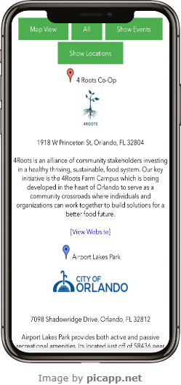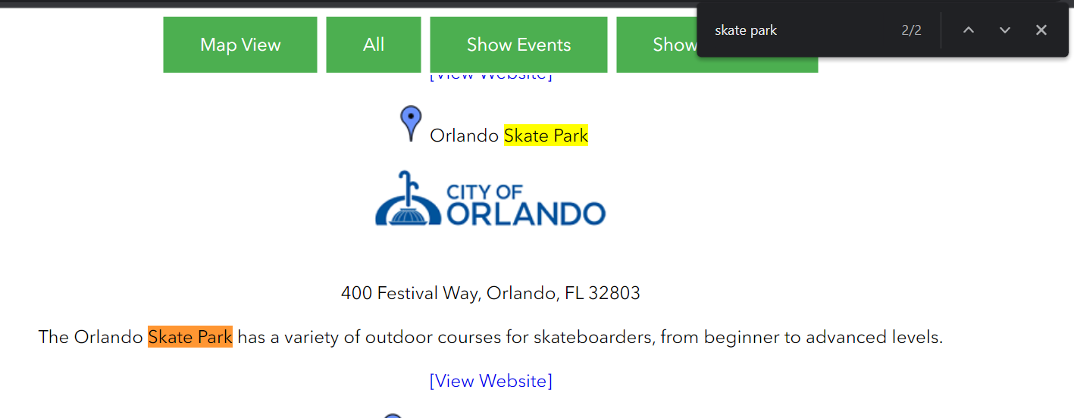

Please see below the functionality of the buttons shown in

the illustration above:

▪ Map View: Returns the user to the interactive map

▪ All: Shows all events on the website

▪ Show events: Shows upcoming events

▪ Show locations: Shows all locations on

the map and there corresponding event